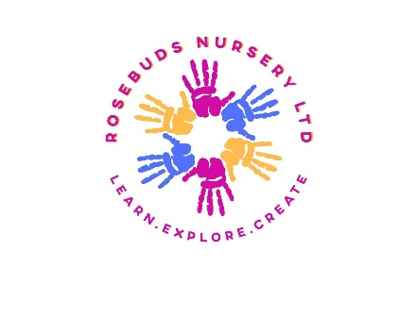Early Learning Opportunities Statement

At Rosebuds Nursery Ltd we promote the learning and development of all children in our care. We have a quality workforce with highly qualified staff who recognise that each child is an individual, focusing on their needs, interests, learning and development. Staff plan challenging and enjoyable experiences across the seven areas of the curriculum. Our staff are ambitious for our children and guide and plan what children learn reflecting on the different rates at which they develop and adjust practice appropriately. Our aim is to support all children attending the nursery to attain their maximum potential within their individual capabilities.

We provide a positive inclusive play environment for every child, so they develop good social skills and an appreciation of all aspects of this country’s multi-cultural society. We plan learning experiences to ensure, as far as practical, there is equality of opportunity for all children and a celebration of diversity.

We maintain a personalised record of every child’s development, showing their abilities, progress, interests and any areas requiring further support.

For children whose home language is not English, we will take reasonable steps to:

* Provide opportunities for children to develop and use their home language in play and learning and support their language development at home; and
* Ensure that children have sufficient opportunities to learn and reach a good standard in English language during the EYFS, ensuring that children are ready to benefit from the opportunities available to them when they begin year one.

We ensure that the educational programmes are well planned and resourced to have depth and breadth across the seven areas of learning. They provide interesting and challenging experiences that meet the needs of all children and reflects the wide range of skills, knowledge and attitudes they will need as foundations for learning. Planning is based on a secure knowledge and understanding of how to promote the learning and development of young children and what they can achieve. We may use the Development matters and Birth to 5 matters for guidance to support staff to plan and deliver the EYFS learning and development requirements.

We implement the Early Years Foundation Stage (EYFS) set by the Department for Education that sets standards to ensure all children learn and develop well. We support and enhance children’s learning and development holistically through play-based activities. We review all aspects of learning and development and ensure a flexible approach is maintained, which responds quickly to children’s learning and developmental needs. We develop tailor-made activities based on observations, which inform future planning and draw on children’s needs and interests. This is promoted through adult-led and child-initiated opportunities both indoors and outdoors.

If we are concerned about a child’s progress in any areas of learning, staff will discuss this with the child’s parents and agree how best to support the child. Staff will consider whether a child may require any additional support, or if they may have a special educational need or disability which will require specialist support. The setting Special Educational Needs Coordinator (SENCo) is: Zoe Wallis (Deputy Manager).

Assessment is an integral part of our practice: we carry out ongoing assessment (formative) through daily observations and ensure that this does not take us away from interacting with the children.

Summative assessment is carried out at set points of the year including:

* Assessment on entry (starting point), including parental contributions. Progress check at age two (where applicable).
* The Early Years Foundation Stage Profile (where applicable) or any other summative assessment, e.g. when children transition to new rooms or leave for school.

We acknowledge parents as primary educators and encourage parental involvement as outlined in our Parents as partners policy. We build strong home links in order to enhance and extend children’s learning both within the nursery environment and in the child’s home and have regular meetings with parents to keep them up to date with their child’s progress.

We share information about the EYFS curriculum with parents and signpost them to further support via the following website: <https://foundationyears.org.uk/>

|  |  |  |
| --- | --- | --- |
| **This policy was adopted on** | **Signed on behalf of the nursery** | **Date for review** |
| *17/06/2024* | Jess Broughton & Becky Newman | *17/06/2025* |